EFFECT OF NANODIAMOND PARTICLES AND DEHYDROGENATED SUPPLEMENTS ONTO THE PROPERTIES OF NATURAL RUBBER MIXURES AND VULKANIZATES
E. Vaysilova, Tz. Tzolov
hrisivais@abv.bg; tzolovtz@abv.bg
University of Chemical Technology and Metallurgy,
8 "Kliment Ohridski" Blvd., 1756 Sofia

Abstract
Current industrial production is interested not only in the properties of the rubber mixtures and vulcanizates but also in the prime coast of rubber devices. Therefore, fresh reinforcing ingredients as well as such obtained from worn out tires and technical goods are including in the current rubber compositions. In the same time, a tendence to addition of very expensive nanoparticles, such as diamond nanoparticles are exists, aimed at the creation of outstanding properties of the vulcanizates. The presence of many functional groups on their surface leads to improvement of both, the filler dispersion and the polymer-filler interaction. Aim of this investigation is to evaluate the effect of both: low filling level with nanodiamond particles as well as their combinations with dehydrogenated supplements (in absence of the conventional carbon black) onto the properties of natural rubber mixtures and vulcanizates. Curing characteristics of the natural rubber mixtures comprising dif ferent amounts of nanodiamond particles were estimated and the mechanical properties of their vulcanizates were tested. DSC analysis was employed to investigate the thermal stability of the studied mixtures. It was carried out that the addition of both: small amounts nanodiamond particles and their combinations with carbon hydrogens leads to improvement of the elasto-hysteresis properties of the vulcanizates.
Introduction
Forecasts of future traffic show that the number of cars in the world will double to 1.5 billion within 30 years from 2000.
Only in the EU, U.S. and Japan each year of operation go more than 6 million tons of tires [1].
Requirements for tires increase: expected to have a long life (high durability), have better grip in dry and wet road conditions and ensure the lowest possible fuel consumption, which is related to rolling resistance and last but not least is the reduction of pollution the environment with harmful emissions [2]. For the manufacture of tires, rubber industry needs innovative technologies and new generation elastomers, fillers and additives to meet the new requirements. In modern technologies is progressing steadily from studies made in the field of nanoparticles. For the first time the introduction of nanodiamonds in the polymer matrix was made by Lukehart [3].
Due to their specific composition and particle size of nanodiamonds are used in various fields such as aviation, automotive, medical, chemical and petro-chemical promshlenost, manufacture of gaskets, tread (protective) coatings and many others [4]. According to a study nanodiamonds produced by detonation synthesis introduced in the rubber matrix, improved physical-mechanical properties of the polymeric materials and composites based on polyisoprene and butadiene-styrene rubber. Composites containing nanodiamonds are characterized by high strength and resistance to fatigue.
Cohesion forces are improved with increasing amounts of nanodiamonds and tear strength almost doubled. Using such composites which containing nanodiamonds, showed higher impact strength parameters [5].
Nanodiamonds are characterized by a high specific surface. It has been found that they can be added in the rubber matrix on the basis of NR and SBR to improve the mechanical properties [6].
According to literature data the optimal effect is achieved by the introduction of nanodiamonds in amounts of from 0.1 to 1.5% in the polymer matrix [7].

Dehydrogenated supplement
Solid waste (carbon black) obtained by vacuum pyrolysis of used tires was used as a raw material for the supplement. For this purpose, the non-destructed during pyrolysis textile and large size (coarse) particles are preliminary separated from the solid rest. The material so obtained was treated with a magnetic separator to remove metal impurities with subsequent repeated micronization to complete processing of the solid residue and to achieve a size fraction of 22 to 150 nm without removal of the initially input into tire fillers [8].
Ecological and economical aspect of this supplement is discussed in detail in [9].
The aim of research is to investigate the influence of dehydrogenated nanodiamond and additive on the properties of rubber compounds and vulcanizates based on natural rubber.
- Experimental
  - Materials:
Based on the literature and conducted preliminary experiments was selected following an elastomeric composition given in Table 1. They are manufactured in two series of 4 compounds of natural rubber base, containing 5.0 phr of zinc oxide, 2.0 phr of stearic acid, 0.5 phr of DFG, 1.5 phr of sulfur, and varies the amount of nanodiamonds from 0 to 1.5 phr. Nanodiamond are added in varying amounts in the first four mixtures, and in the following four mixtures was added and dehydrogenated additive 70 phr (Table 1).

Table 1. Composition of the investigated rubber compounds
Code of the  mixture  Ingredients  [mass fraction] | E1 | E2 | E3 | E4 | E1S | E2S | E3S | E4S
Natural rubber (SVR10) | 100 | 100 | 100 | 100 | 100 | 100 | 100 | 100
ZnO | 5 | 5 | 5 | 5 | 5 | 5 | 5 | 5
Stearic acid | 2 | 2 | 2 | 2 | 2 | 2 | 2 | 2
Sulfur | 1.5 | 1.5 | 1.5 | 1.5 | 1.5 | 1.5 | 1.5 | 1.5
CBS | 2 | 2 | 2 | 2 | 2 | 2 | 2 | 2
DPG | 0.5 | 0.5 | 0.5 | 0.5 | 0.5 | 0.5 | 0.5 | 0.5
Nanodiamonds | 0.00 | 0.50 | 1.00 | 1.50 | 0.00 | 0.50 | 1.00 | 1.50
Dehydrogenated supplement | 0.00 | 0.00 | 0.00 | 0.00 | 70.00 | 70.00 | 70.00 | 70.00

Legend:
1. DPG –Diphenyl Guanidine
2. ZnO - Zinc Oxide
3. CBS – N-Cyclohexyl-2-Benzothiazole Sulfenamide

  - Methods
    - Production of rubber compounds
Development of rubber compounds was carried out on an open laboratory rubber mixer (rollers) with dimensions: L/D 400x150 and friction 1:1.17, time 18 minutes. It was made eight rubber mixtures with different quantities of nanodiamond, respectively 0, 0.5, 1.0, 1.5 phr on the basis of natural rubber. The finished mixture, taken from the rollers in the form of a thick sheet was allowed to stand for 24 hours before being analysing, testing or vulcanization.
    - Determination of the vulcanization characteristics of the rubber mixes
Optimal time of vulcanization of the mixtures of the matrix was determined by vulcanization isotherms, taken with oscillating disc vulkametar "Monsanto" (MDR 2000) at temperatures 140⁰C, 150⁰C, 160⁰C, according to ISO 3417:2002.
    - Vulcanization of test pieces
Test specimens were cured on a hydraulic press with electrically heated in the optimum curing of each mixture at the relevant temperature and pressure.
    - The strength-elastic properties of vulcanizates
Stress-elastic properties of the vulcanizates were studied according to ISO 37:2002.

    - Determination of the hardness of the studied ShorA vulcanizates
ShorA hardness of vulcanizates was determined according to ISO 7619:2001.

    - Differential Scanning Calorimetry (DSC)
Differential scanning calorimetry of the mixtures is made on STA RT1600 TG-DTA/DSC (STA Similtaneios Termal Analysis), produced by LINSEIS Messgerate GmbH, Germany with the following parameters:
Temperature range: 20-1550⁰C (to 1000⁰C in a static gas environment);
Heating rate :0,1-100⁰C / min;
Quantity of sample: 50-100 mg;
Atmosphere: static air gas environment;
Type of pot: Type S (Pt10% / Pt-Rh) - stabilized corundum and platinum pots.

- Results and discussion
To achieve the objective of the study are set vulcanization characteristics of rubber compounds (identified by their vulcanization isotherms) at 140⁰C, 150⁰C, 160⁰C. The data are summarized in Tables 2, 3 and 4.

Table 2. Vulcanization characteristics at 140⁰C
Characteristics | Е1 | Е2 | Е3 | Е4 | Е1s | Е2s | Е3s | Е4s
Minimum torque, ML, dNm | 0.64 | 0.23 | 0.31 | 0.34 | 0.65 | 0.48 | 0.68 | 0.51
Maximum torque, MН, dNm | 11.71 | 11.18 | 11.22 | 11.08 | 20.30 | 19.40 | 18.99 | 18.48
ΔМ=MН - ML | 11.07 | 10.95 | 10.91 | 10.43 | 19.65 | 18.92 | 18.31 | 17.97
Т_{s2}, min:s | 6:25 | 5:30 | 5:01 | 4:26 | 3:46 | 3:35 | 3:12 | 3:29
T₉₀, min:s | 12:23 | 10:16 | 9:30 | 8:42 | 7:30 | 7:12 | 6:45 | 7:10
V,%/ min. | 17 | 21 | 22 | 24 | 27 | 27 | 29 | 27

Table 3. Vulcanization characteristics at 150⁰C
Characteristics | Е1 | Е2 | Е3 | Е4 | Е1s | Е2s | Е3s | Е4s
Minimum torque, ML, dNm | 0.65 | 0.22 | 0.28 | 0.29 | 0.56 | 0.43 | 0.53 | 0.51
Maximum torque, MН, dNm | 12.08 | 11.40 | 11.39 | 11.21 | 20.00 | 19.05 | 18.91 | 18.45
ΔМ=MН - ML | 11.43 | 11.18 | 11.11 | 10.92 | 19.44 | 18.62 | 18.38 | 17.94
Т_{s2}, min:s | 3:36 | 3:01 | 2:50 | 2:41 | 2:02 | 1:59 | 1:53 | 1:56
T₉₀, min:s | 7:13 | 5:58 | 5:31 | 5:04 | 4:14 | 3:56 | 3:50 | 3:51
V,%/ min. | 27 | 33 | 40 | 40 | 44 | 50 | 57 | 57

Table 4. Vulcanization characteristics at 160⁰C
Characteristics | Е1 | Е2 | Е3 | Е4 | Е1s | Е2s | Е3s | Е4s
Minimum torque, ML, dNm | 0.60 | 0.18 | 0.29 | 0.28 | 0.53 | 0.42 | 0.49 | 0.51
Maximum torque, MН, dNm | 11.47 | 10.47 | 10.87 | 10.70 | 19.16 | 18.40 | 18.35 | 17.90
ΔМ=MН - ML | 10.87 | 10.29 | 10.58 | 10.42 | 18.63 | 17.91 | 17.86 | 17.39
Т_{s2}, min:s | 2:04 | 1:48 | 1:39 | 1:37 | 1:11 | 1:11 | 1:10 | 1:11
T₉₀, min:s | 3:50 | 3:19 | 2:53 | 2:46 | 2:34 | 2:16 | 2:10 | 2:08
V,%/ min. | 67 | 57 | 80 | 80 | 80 | 100 | 100 | 100

Table (2) shows that minimum torque (ML), which serves as a measure of the viscosity of the rubber compounds for mixtures E2 EZ, E4 is reduced approximately two-fold compared to the standard E1. It is almost the same in case of filled elastomer mixtures F1s, E2s, E3s, and E4s.
Maximum torque (MH) for unfilled mixtures containing nanodiamond slightly reduced compared to the standard. The same was observed for filled rubber mixtures containing nanodiamonds. It is believed that the difference between the minimum and maximum torque (ΔM) gives even an idea of the density of the vulcanization network. ΔM remains equal in unfilled mixtures, while in the filled mixtures ΔM is slightly reduced. The optimal time for curing decreased with increasing amount of nanodiamonds in the filled and unfilled mixes. The speed of cure increases compared to the standard in unfilled mixtures and decreases in filled. The same trend is observed in vulcanizates prepared with the 150⁰C and 160⁰C (Tables 3 and 4). Compared to the standard an increase of the rate of vulcanization during 150⁰C and 160⁰C in both series of test rubber mixtures is observed.
It is determined the main physical and mechanical properties of vulcanizates of rubber mixtures studied at 150⁰C. The results obtained are presented in Table 5.

Table 5. Physicomechanical parametars of the vulcanizates at 150⁰C
Characteristics | Е1 | Е2 | Е3 | Е4 | Е1s | E2s | Е3s | Е4s
Voltage (Tension) at 100% deformation M_{100,}MPa | 1.0 | 0.9 | 0.9 | 0.9 | 2.6 | 2.6 | 2.4 | 2.2
Voltage (Tension) at 300% deformation M₃₀₀,MPa | 2.5 | 2.5 | 2.5 | 2.3 | 8.9 | 8.3 | 8.3 | 8.1
M₃₀₀/M₁₀₀ | 2.5 | 2.8 | 2.6 | 2.5 | 3.4 | 3.2 | 3.4 | 3.6
σ, МРа | 26.2 | 24.9 | 26.2 | 24.2 | 24.4 | 23.5 | 23.8 | 23.3
ε_{rel.}, % | 609 | 617 | 635 | 605 | 587 | 570 | 595 | 583
ε_{res.}, % | 10 | 10 | 10 | 10 | 15 | 20 | 20 | 25
Hardness Shore A | 53 | 51 | 53 | 53 | 65 | 65 | 65 | 66

It is seen from Table 5 that the voltage at 100% deformation (M₁₀₀) of vulaknizatites from unfilled and filled rubber mixtures involving nanodiamond slightly reduced.
Tension at 300% deformation (M₃₀₀) of the vulcanizates and the two series is also slightly reduced. At low values of stress at 100% and 300% strain were observed in the two series of vulcanizates containing the greatest amount of nanodiamonds. Ratio M₃₀₀ / M₁₀₀, which serves as a measure of the reinforcing effect of the filler did not change significantly as for unfilled and filled in rubber mixtures with different amounts of the nanodiamond. The tensile strength of vulcanizates of the unfilled rubber mixture is nearly identical - about 25MPa. When filled, it is approximately 24 MPa. Compared to the reference, and the two series to the tensile strength slightly decreases with increasing the amount of nanodiamonds. The elongation of unfulled vulcanizates is slightly larger than the filled.
For the determination of the thermal behavior of the test mixtures was compounded used differential scanning calorimetry (DSC). It allows quantification of the changes in enthalpy (registration of differences in heat flow as a function of time ΔH=f(t)) and determines: amount of heat generated by the flow of the process, heat of reaction, specific heat capacity of sample surveys; heat of phase and chemical transformations [10].
Thermal analysis of samples was performed at:
Operating temperature 800⁰C; (In a static gas environment)
Heating rate of 10⁰C/min;
Quantity of sample ranging from 13.3 to 23 mg;

The results obtained are shown in Figures 1, 2, 3, 4 and 5.
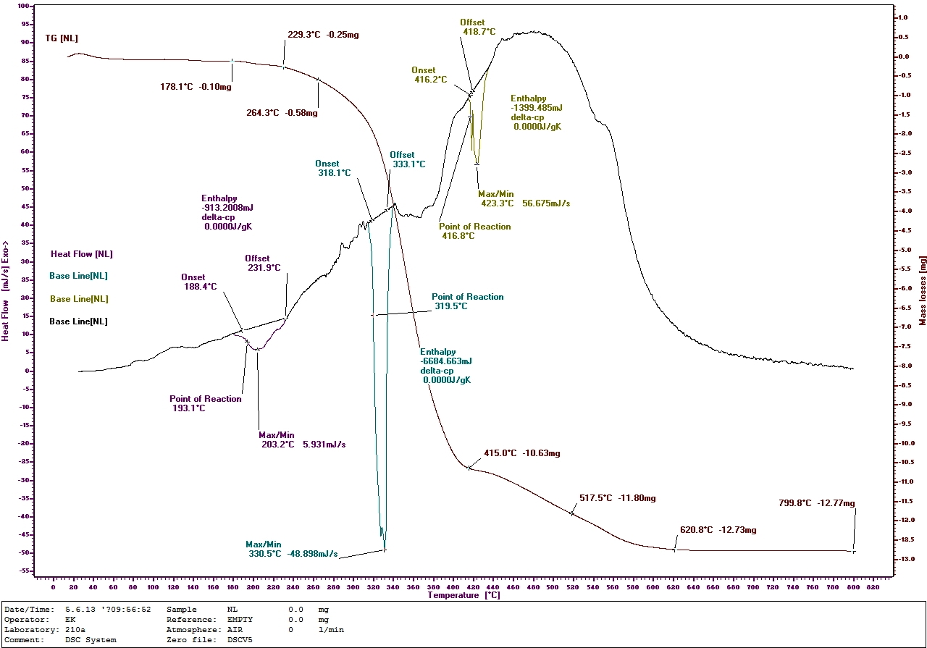
Fig. 1 (contains only nanodiamond and latex) mass of the specimen е 13,3 mg

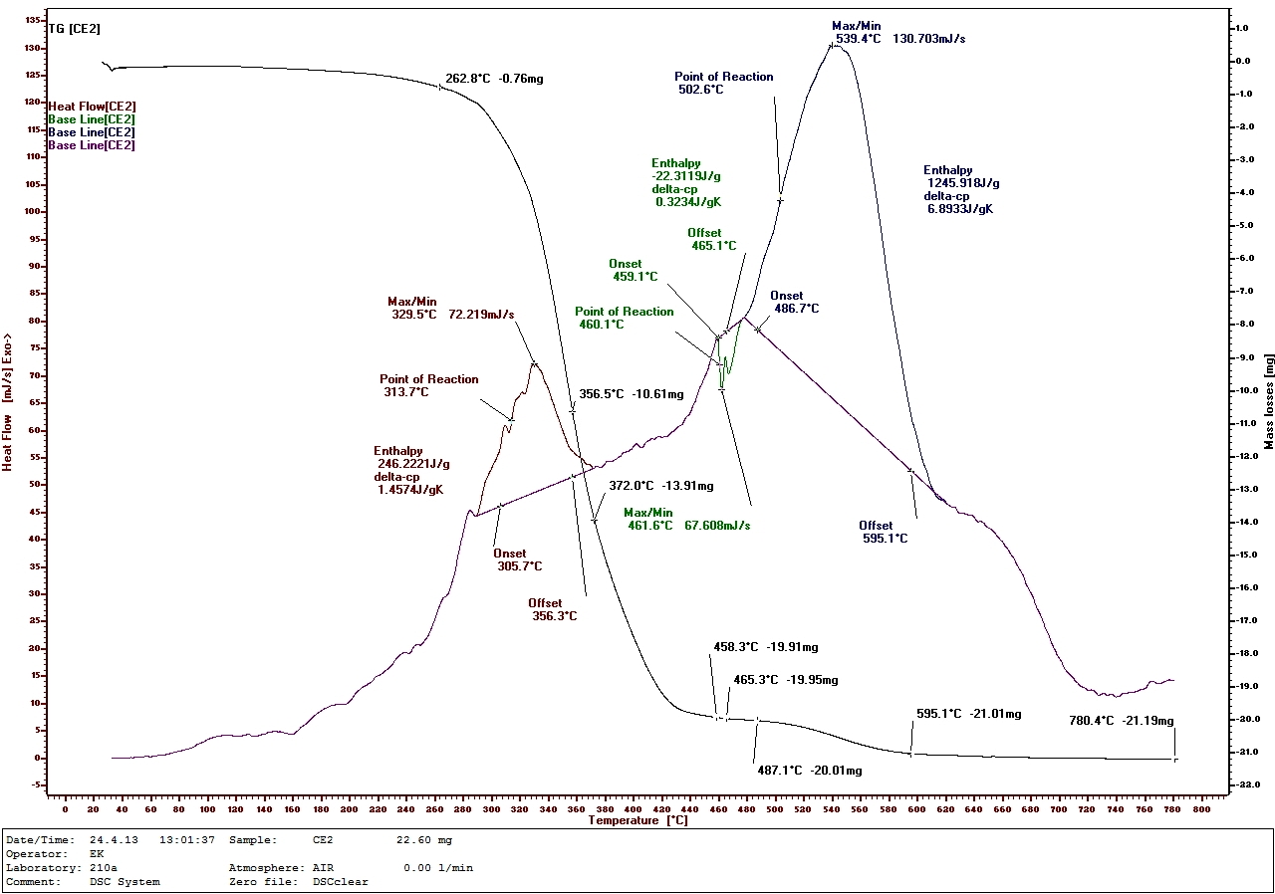
Fig. 2 (mixture E2, unfilled, containing 0.5 mass fraction nanodiamonds)
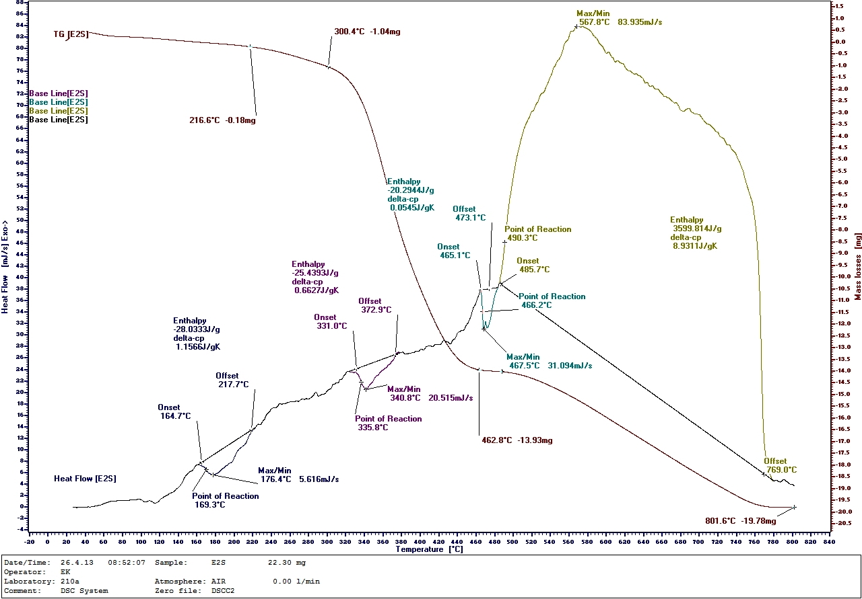
Fig. 3 (mixture Е2S filled, containing 0.5 mass fraction nanodiamonds)
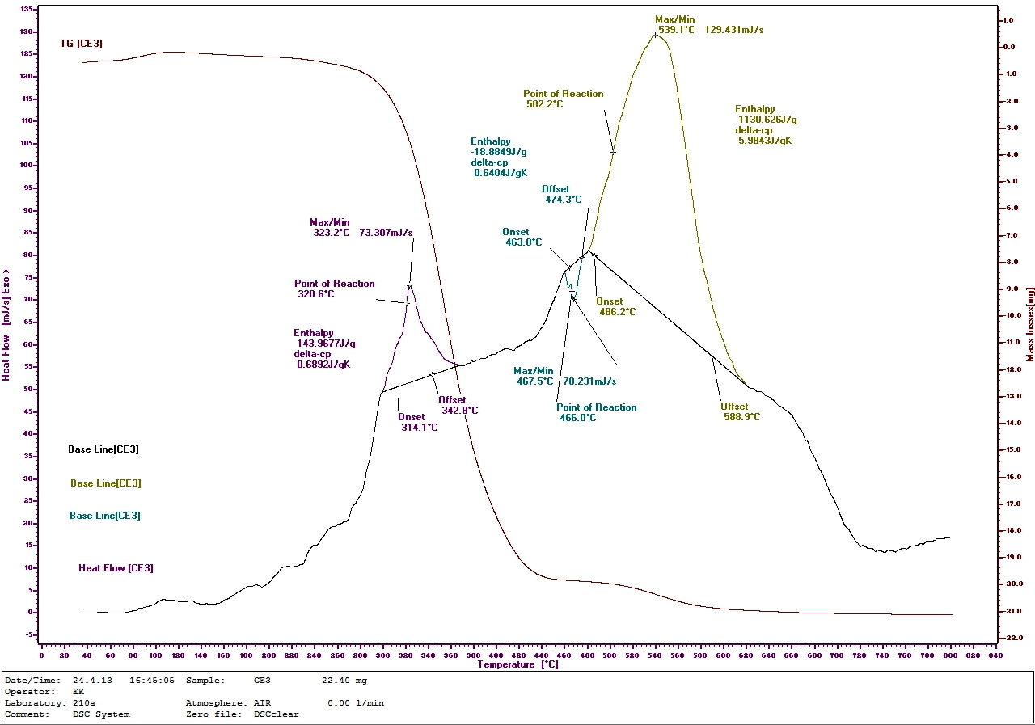
Fig. 4 (mixture Е3 unfilled, containing 1.0 mass fraction nanodiamonds)
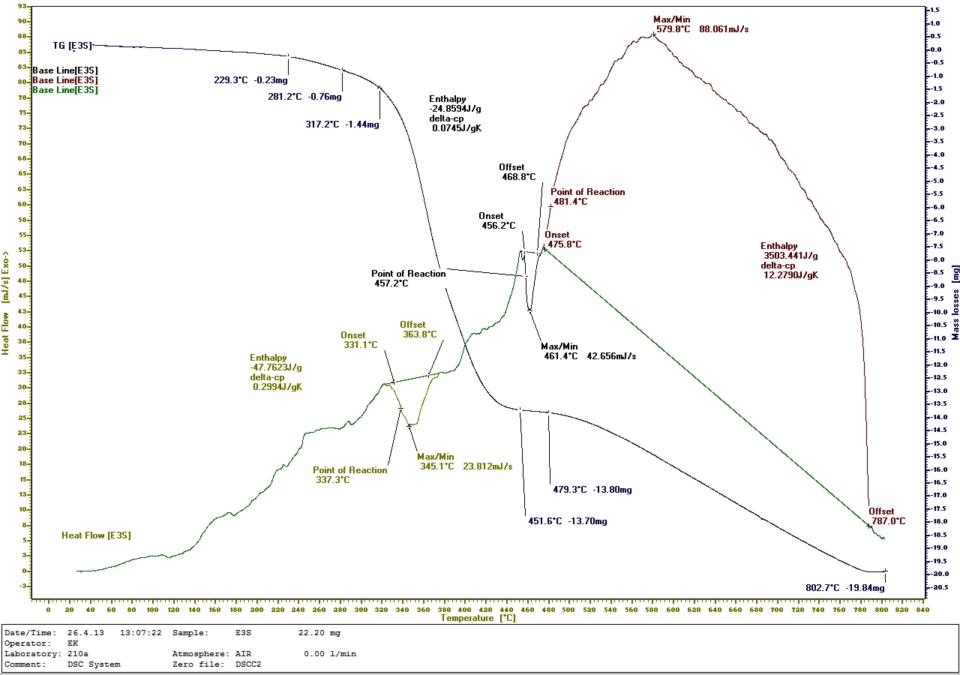
Fig. 5 (mixture Е3S filled, containing 1.0 mass fraction nanodiamonds)
DSC analysis demonstrated the lowest mass loss of filled by 0.5 phr and 1.0 phr nanodiamonds.

- Conclusions
- The modulus of elasticity increases in filled blends dehydrogenated additive.
- High mechanical properties are obtained by curing at a temperature of 150⁰С.
- The addition of small amounts of nanodiamonds in the elastomeric mixtures containing dehydrogenated hydrocarbons leads to improvement of the elasto- hysteresis properties of the vulcanizates.

References:
[1] S.Galvagno, S. Casu, T. Casabianca, A. Calabrese, G. Cornacchia, Waste Manag. 22 (2002) p. 917 – 923.
[2] Tzolov T., Avtomobilni gumi, 2003, UCTM, Sofia,p. 9-15
[3] S. Osswald, G. Yushin, V. Mochalin, S. O. Kucheyev and Y. Gogotsi,J. Am. Chem. Soc., 2006, 128, 11635–11642.
[4] Dolmatov V.,Detonation synthesis ultradispersed diamonds: properties and applications, Soverskii prosp., 33A, Uspehi himii, 70 (7) 2001
[5] Journal of Superhard Materials Volume 29, Number 2 , 65-75 , DOI: 10.3103/S1063457607020013 Production, Structure, Properties Polymer-diamond composites based on detonation nanodiamonds. Part 2
[6] Influence of Nano-diamond on Mechanical Properties of Rubber Liu Xiao-xin,ZHOU Gang,WEH Chao,SUN De-yu (Northwest Institute of Nuclear Technology,Xian 710024,China
[7] Danilenko V. Sintez I spekanie almaza vzrivom. – М.: Energoatomizdat т, 2003 -181 p.
[8] R. Bulgaria, Useful Model №1642, pulblished 01.02.2013
[9] Stefanov S.,Enviromental and economic aspects of the applicattion of the solid product of tire recycling, UNWE, Sofia,2013
[10] Vladkova Т., Analys i izpitvane na Elastomeri , 1997, UCTM, Sofia, p. 209 – 215

