INFLUENCE OF XYLENE ON THE TEXTURAL FEATURES OF THE HYBRID GEL MATERIALS
Nina E. Velikova^{1*}, Yuliya E. Vueva¹, , Yordanka Y. Ivanova¹,
, Isabel M. Salvado² and Maria H. Fernandes²
¹ Department of Silicate Technology, University of Chemical Technology and Metallurgy,
Sofia, 1756, Bulgaria
²Ceramic and Glass Engineering Department CICECO, University of Aveiro, Aveiro,
3810-193, Portugal

Mesoporous hybrid- organic-inorganic silicas with amine bridging group within the framework were synthesized by co-condensation of BTPA and TEOS under acidic conditions in the presence of amphihilic triblock-copolymer poly (ethylene oxide)-block-poly(propylene oxide)-block-poly(ethylene oxide) (PEO₂₀PPO₇₀PEO₂₀), commonly known by the trade name Pluronic P123), as a structural directing agent for obtaining of mesoporous structure, and xylene as swelling agent. In our work we investigate the influence of the xylene amount on the pore size and surface area of the final hybrid materials. The resultantmaterials were true hybrids confirmed by ²⁹Si MAS NMR and ¹³C CP MAS NMR analyses. Increasing the amount of xylene slightly decreased the mesopore size of all hybrids with high content of TEOS. The compositions with highest content of BTPA showed most significant increase in pore size due to the higher amount of the flexible organic chains present in the structure that make the framework more flexible and collapse resistant.

Kaywords: sol-gel, mesoporous materials, hybrid materials, surfactant, pore swelling agent.

- Intoduction
Mesoporous materials have gained a lot of interest in recent years, because of the possibility of tailoring the pore structure, framework composition, and morphologies over a wide range [1]. According to the IUPAC definition, porous materials with pore diameter in the 2-50 nm range are called mesoporous[2].
The traditional methods to control the pore size of mesoporous materials are the addition of templates with different lengths of hydrophobic chains as well as the use of an organic swelling agent. Most often as templates are used surfactants. They are organic molecules, which comprise two parts with different polarity [3]. One part is a hydrocarbon chain, which is nonpolar and hence hydrophobic, whereas the other is polar and hydrophilic. Surfactant molecules can be generally classified into four families, and they are known as nonionic, anionic, cationic, and amphoteric surfactants. Swelling agents have been extensively applied in the surfactant-templated synthesis of mesoporous materials.
The swelling agent is solubilized in the hydrophobic cores of the micelles and thus it increases their diameter and volume, leading to the enlarged pore size and increased pore volume of the surfactant-templated material. By tailor of the pore size many potential applications arise from the promising properties of these materials, including separation technology (chromatography, membranes, etc.), catalysis, nanoelectronics, sensors, and spatially defined host materials for substances or reactions.[1, 4].
Preparation of the functionalized mesoporous silicas with organic moieties soon became a major topic of research because it offered a further possibility of tailoring the physical and chemical properties of the porous materials. The functionalization of mesoporous materials usually has two methods [5,6]. One is grafting, also called post-synthesis, which refers to the attachment of functional groups to the surface of the mesoporous materials, usually after surfactant removed. It includes the reaction of organosilanes with the surface silanol groups of mesoporous silica. Co-condensation is the secound one method to modify mesoporous materials by sol–gel chemistry. It include co-condensation of tetraalkoxysilane, for instance tetraethoxysilane (TEOS), and organosilanes with Si–C bonds. It is also called one-pot synthesis. Compared with grafting method, co-condensation method can easily achieve greater control over functional group loading and surface uniformity. These mesoporous materials contain organic and inorganic groups are called “hybrid mesoporous silica materials”.The organic functionalization of these solids permits the tuning of the surface properties (hydrophilicity, hydrophobicity, and binding to guest molecules); alteration of surface reactivity; protection of the surface from attack; and modification of the bulk properties (e.g., mechanical or optical properties) of the material [7].
In this work, mesoporous silicas were fabricated by co-condensation reaction of TEOS and BTPA using amphiphilic triblock-copolymer poly (ethylene oxide)-block-poly(propylene oxide)-block-poly(ethylene oxide) (PEO₂₀PPO₇₀PEO₂₀) available under the trade name Pluronic P123, and xylene as a hydrophobic swelling agent. Our goal here is to investigate the effect of xylene on the pore size in the hybride material. The structure and morphology of the final mesoporous hybrid materials were investigated by nitrogen gas sorption, SEM, ²⁹Si MAS NMR and ¹³C CP MAS NMR technics.

EXPERIMENTAL

Chemicals
Bis[(3- trimethoxysilyl)propyl] amine (BTPA, Aldrich ) and tetraethyl orthosilicate (TEOS, MERCK) were used in order to synthesize the amine-functionalized porous gels. As a structure directing agent was used amphiphilic triblock copolymer Pluronic P123 PEO₂₀PPO₇₀PEO₂₀, (Sigma-Aldrich, Mn~5,800). Xylene (Aldrich) was used as a swelling agent. To improve the structure ordering and tailor framework porosity was used KCl (Aldrich). Ethanol (99.8%), hydrochloric acid (HCl, 32%, Promark Chemicals) and distilled water were used for removal of surfactant.

Synthesis
The gel materials were prepared through a one-pot sol–gel process catalyzed by the –NH– groups of BTPA. In a typical synthesis (Sheme 1.) 1.2g P123 and 3.5g KCl were dissolved in solution of 52 ml 2M HCl and 10 ml distilled water with stirring at 20 ºC. Xylene was added after dissolving of KCl and P123.To this homogeneous solution TEOS was added and then the mixture was stirred for 1 hour at the same temperature. After homogenization of this mixture BTPA was added (drop-by-drop) under continuous stirring. The sample composition is presented in Table 1.
After gelation, gels were allowed to stand for 2 days for aging at 100 ͦ C.

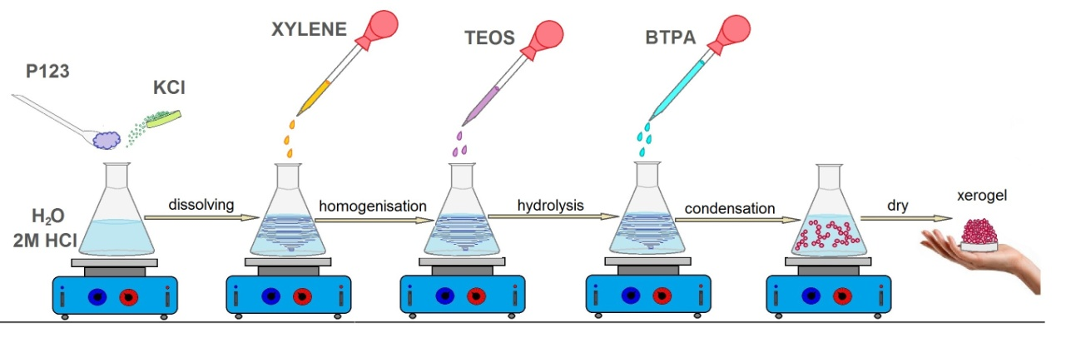
Sheme 1. Synthesis of the hybride gel materials.

Table 1. Chemical composition of the gels
Sample | KCl  [g] | HOH  [ml] | 2M HCl  [ml] | P123  [g] | Xylene  [ml] | TEOS  [ml] | BTPA  [ml]
AHM 1 | 3.5 | 10 | 52 | 1.2 | 0 | 2.64 | 1.16
AHM 2 | 3.5 | 10 | 52 | 1.2 | 1.32 | 2.64 | 1.16
AHM 3 | 3.5 | 10 | 52 | 1.2 | 2.64 | 2.64 | 1.16
AHM 4 | 3.5 | 10 | 52 | 1.2 | 2.64 | 1.24 | 1.16
AHM 5 | 3.5 | 10 | 52 | 1.2 | 2.64 | 2.64 | 3.90

  - Surfactant extraction
The surfactant was removed by soaking 1.0 g of as-synthesized sample in 150 ml of ethanol and 1.7 ml of 36% HCl solution at 60 ºC for 24 hours. The resulting solid was recovered by filtration, washed with ethanol, and dried in oven at 60 ºC for 24 hours. This material is referred to as the surfactant extracted material.

  - Materials characterization
The specific surface area and the pore size distribution of the resultant materials were determined by nitrogen adsorption: nitrogen adsorption and desorption isotherms were measured at liquid nitrogen temperature using a Geminy 2370 instrument. The BET surface areas were calculated based on the adsorption data in the relative pressure range of 0.001–0.20. Pore size distributions were determined based on the Barrett-Joyner-Halenda (BJH) desorption curve [8].
The morphology of the samples was observed by scanning electron microscopy (SEM) the images were recorded on a Hitachi S-4100 scanning electron microscope with an acceleration voltage of 15 kV. ¹³C (100.61MHz) cross-polarization magic angle spinning (CP MAS) and ²⁹Si (79.49 MHz) MAS solid-state NMR experiments were recorded on a (9.4 T) Bruker Avance 400 spectrometer. The experimental parameters for ¹³C CP MAS NMR experiments: 9 kHz spin rate, 5 s pulse delay, for ²⁹Si MAS NMR experiments: 5 kHz spin rate, 60s pulse delay. MAS NMR spectra were measured with 40 μs 1H 90º pulse, speed of rotation 50 kHz. ²⁹Si solid-state NMR spectra were recorded at 79.49 MHz on a (9.4 T) Bruker Avance 400 spectrometer ²⁹Si magic angle spinning MAS NMR spectra were measured with 40 μs 1H 90º pulse, speed of rotation 50 kHz and a delay of 60 seconds.

- RESULTS AND DISCUSSIONS
²⁹Si MAS NMR spectra of the synthesized hybrid materials (Figure 1.) clearly express resonant peaks, at 110 ppm, 101 ppm and 92 ppm, respectively, as indicated Q⁴ [Si (OSi) ₄], Q³ [(OH) Si (OSi)₃] and Q² [(OH)₂ Si (OSi)₂] and another three about 66 ppm, 57 ppm and 50 ppm are designated as T³ [(SiO)₃SiC], T² [(SiO)₂ (OH) SiC] and T¹ [(SiO) (OH )₂SiC] [9,10]. The appearance of the T^{m} peaks confirms that organic silane (BTPA) is included as part of the structure this means that the materials are organic-inorganic hybrids [11-13]. The appearance of Q³, Q², T² and T¹ silicon species shows that the condensation between the both silicate precursors is not completed , with unreacted silanol groups still being present. The intensity of T³ peaks increase whereas the intensity of T¹ and T² peaks decrease with increasing BTPA amount. This can be explain as a result of increased amine group concentration which catalysed the condensation reaction. The Q^{n} peaks are characteristic for TEOS precursor. The intensity of Q^{n} peaks decrease because the ratio TEOS/BTPA in the mixture decrease.The relative integrated intensities of the T^{m} and Q^{n} signals in T^{m}/(T^{m} + Q^{n}) were found to increase from 0.40 to 0.68 respectively, with increasing of the ratio BTPA/(BTPA +TEOS) in the initial mixture [11]. These results indicate that the bridging organic part in the pore walls increases with increasing the amount of BTPA [11,13].
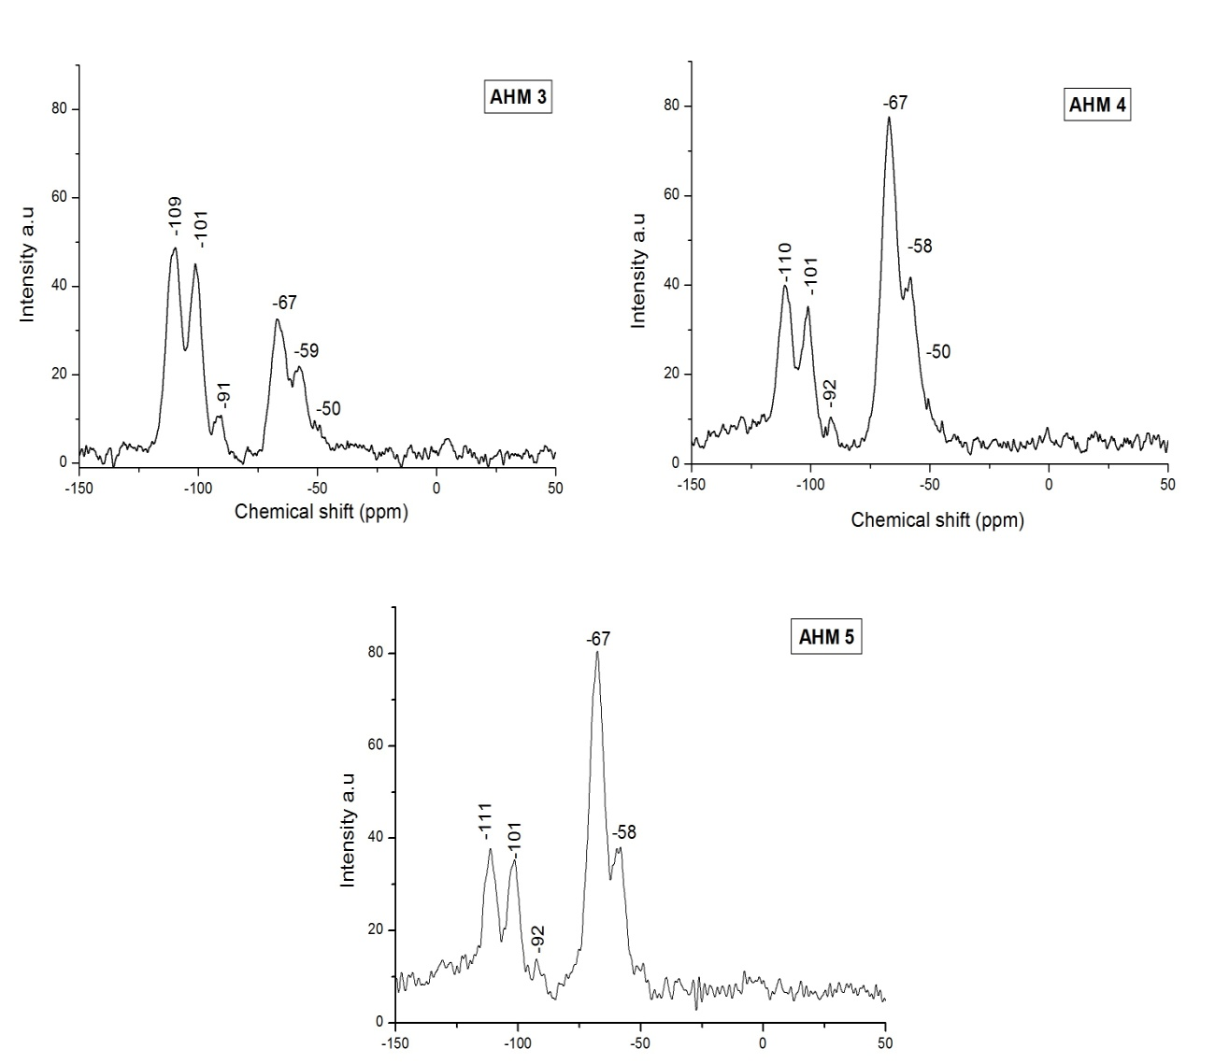
Figure 1. ²⁹Si MAS NMR spectra of AHM 3, AHM 4 and AHM 5 hybrid materials

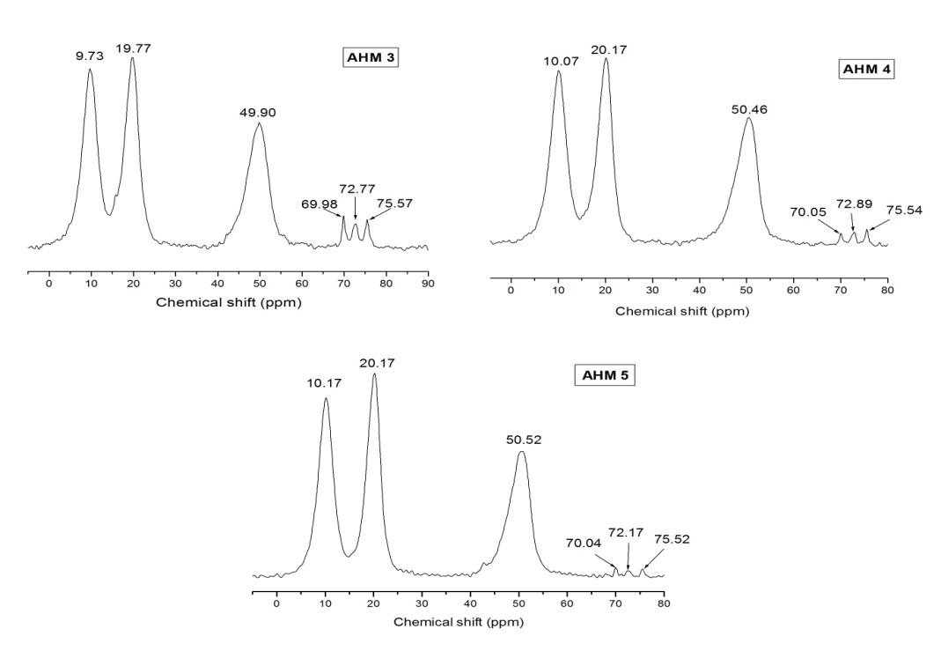
¹³C CP MAS NMR results of the samples AHM 3, AHM 4 and AHM 5 (Figure 2) show resonans peaks at around 10, 20 and 50 ppm, typical of sp³ carbon atoms which characterize organic bridging group of BTPA [19-21]. The three most intense peaks at around 10, 20 and 50 ppm correspond to the carbon atoms of the bridging group in the direction from left to right, ≡Si−CH₂ −CH₂−CH₂ −NH−CH₂−CH₂−CH₂−Si≡ [22,23]. The peaks in the range from 70 to 75 ppm indicate the presence of surfactant P123 in the materials pores i.e. not completely extracted from the pores by soaking [22-24]. These results explain the reason for the small pore size, pore volume and surface area of the organic-imorganic hybrid gel materials.
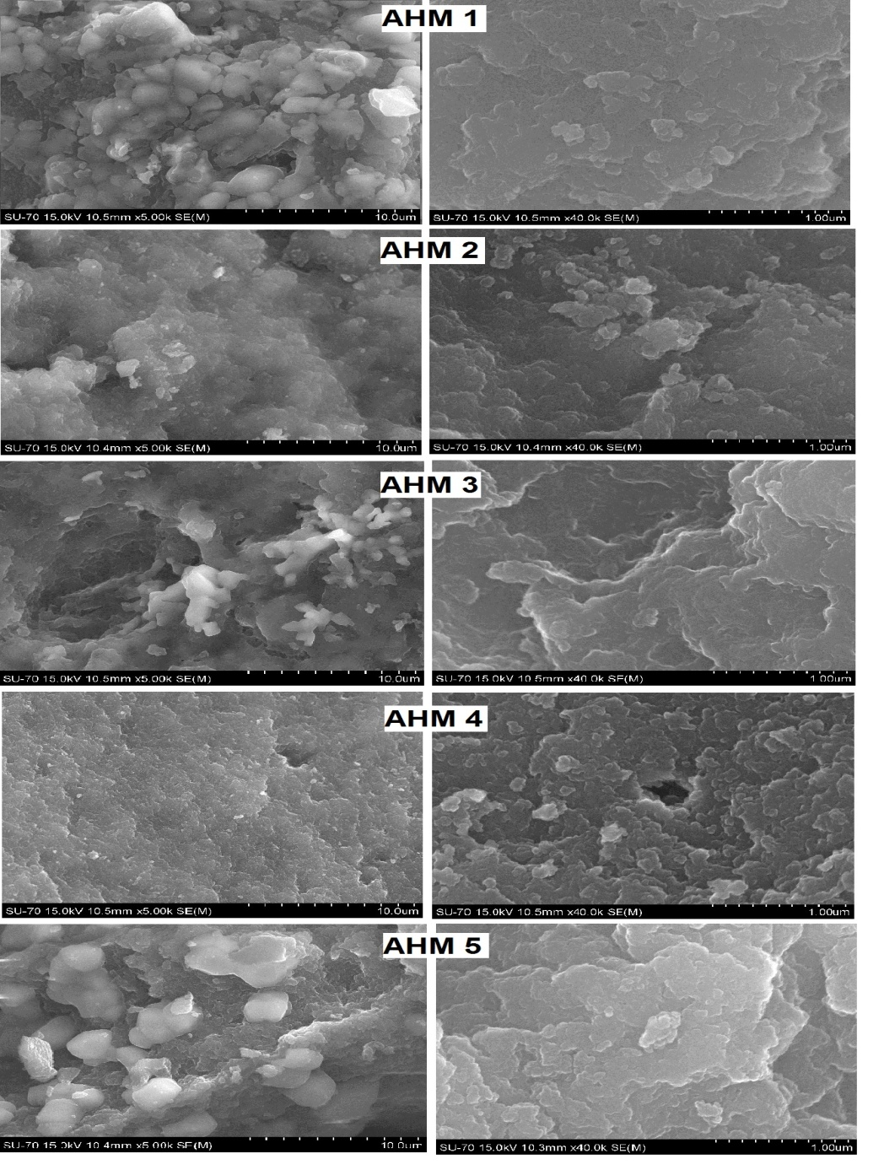
Figure 2. .. ¹³C CP MAS NMR spectra of the synthesized gels.SEM images of the synthesized hybrid gel materials are shown in Figure 3. They show the significant influence of xylene amount on the materials surface after the surfactant extraction. Sample AHM 1 shows the smoothest surface than the other gels. By increasing of xylene amount (AHM 2 and AHM 3) occurs coarsening of the materials surface. Gel materials AHM 4 and AHM 5 also show the influence of the BTPA amount on the morphology. Sample AHM 4, synthesized with 3.9 ml BTPA shows the coarsest surface than all the other gels.
Figure 3. SEM images of the synthesized gels

The porous structure of the hybred gels was determined by N₂ adsorption-desorption measurements and the results are presented in Figure 4 and Table 2. According to IUPAC classification, the shape of the adsorption isotherm can be classified as Type IV [14,15]. Type IV isotherms are typical for mesoporous materials (average pore size is in the range between 2-50 nm). The hysteresis loop is due to pore condensation. At low pressures, first an adsorbate monolayer is formed on the pore surface, which is followed by the multilayer formation. The adsorption/desorption curves of the hybrid materials show hysteresis loops that resemble the H2 type in the IUPAC classification [14]. The H2 hysteresis loop has a smoother adsorption step and a sharp desorption step. It is typical for materials with nonuniform pore shapes and/or sizes. The H2 type adsorption hysteresis is associated with pores with ink-bottle shapes or more complicated interconnectivity of pores forming porous network. [16-18]. The results show that with increasing of xylene amount, in the sample synthesized with 2.64 ml TEOS and 1.16 ml BTPA the surface area increase and pore size decrease. This can be explain with destruction of the pores after the surfactant extraction. The samples synthesized with higher amount BTPA in the solution (AHM 4 and AHM5) show significant increasing of pore size. This is perhaps a result of increased amount of the flexible organic chains that perhaps make the framework more flexible and collapse resistant.
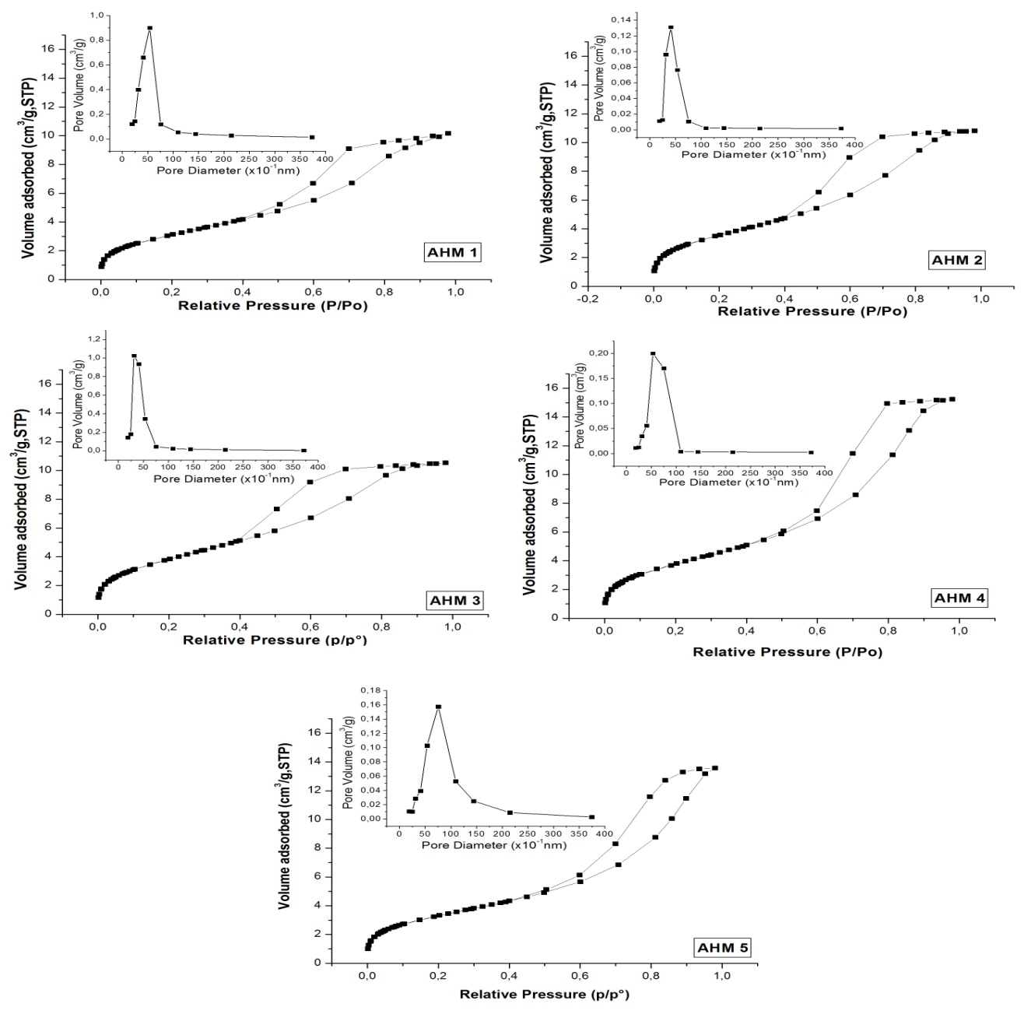
Figure 4. N₂ adsorption-desorption measurements.of the hybride gel materials

Table 2.. Texture parameters of amine functionalized organosilica samples.
Sample | Pore volume [cm³/g] | Surface area [m²/g] | Pore size [nm]
AHM 1 | 0.32 | 250 | 4.3
AHM 2 | 0.35 | 286 | 3.8
AHM 3 | 0.33 | 307 | 3.5
AHM 4 | 0.49 | 306 | 5.1
AHM 5 | 0.44 | 267 | 5.8

CONCLUSIONS
On the basis of the obtained results we can conclude that the synthesized materials were mesoporous organic- inorganic hybrids. The appearance of T sites in ²⁹Si MAS NMR and the peaks at 10 ppm, 20 ppm and 50 ppm in ¹³C CP-MAS NMR spectra confirm the presence of organic groups in the silica framework i.e these are organic-inorganic hybrid materials. ²⁹Si MAS NMR spectra showed Q3, Q2, T1 and T2 type structural units which is indicative of incomplete condensation reactions. The increasing of relative integrated intensities of the Tm and Qn units suppose that the amount of organic moiety in the silica wall structures increases with BTPA concentration. The peaks in ¹³C CP-MAS NMR spectra that correspond to surfactant P123 imply the incomplete removal of surfactant P123 during the extraction. BET results showed that with increasing xylene amount leads to decreasing of pore size and increasing of surface area of the hybrid materials as a result of destruction of the pores after the surfactant extraction. These results are confirmed by SEM analysis which show coarsening of the materials surface with increasing of xylene amount. SEM images of the sample AHM 3 and AHM 4 show coarsest surface than all the other gels, which is in agreement with BET results. The BET results for the samples synthesized with 2.64 ml xylene and highest BTPA amount show significant increase in pore size, perhaps as a result of increased amount of the flexible organic chains that make the framework more flexible and collapse resistant.

ACKNOWLEDGEMENTS
This paper has been produced with the financial assistance of the European Social Fund, project
number BG051PO001-3.3.06-0014. The author is responsible for the content of this material, and
under no circumstances can be considered as an official position of the European Union and the
Ministry of Education and Science of Bulgaria.

REFERENCES
[1] Kickelbick, G. Angew Chem Int Ed (2004), 43, 3102
[2] K.S.W. Sing, D.H. Everett, R.A.W. Haul, L. Moscou, R.A. Pierotti, J. Rouquerol, T. Siemieniewska, Pure Appl. Chem. 57 (1985) 603
[3] A. Berthod, J. Chim Phys. (Fr.) 80, 407 (1983).
[4] Stein, A. Adv Mater (2003), 15, 763
[5] M.H. Lim, C.F. Blanford, A. Stein, Chem. Mater. 10 (1998) 467.
[6] A. Stein, B.J. Melde, R.C. Schroden, Adv. Mater. 19 (2000) 1403
[7] Stein, A.; Melde, B. J.; Schroden, R. C. Adv Mater 2000, 12, 1403
[8] P. J. Kooyman, M. J. Verhoef, E. Proozet, Stud. Surf. Sci. Catal. 129 (2000) 535-542.
[9] M. Llusar, G. Monrós, C.Roux, J. L. Pozzo, C. Sanchez, J. Mater. Chem., 13, (2003) 2505–2514.
[10] Y. Q. Wang, C. M. Yang, B. Zibrowius, B. Spliethoff, M. Linde, and F. Schüth, Chem. Mater. 15, (2003) 5029-5035.
[11] X. Wang, K. S. K. Lin, J. C. C. Chan, S. Cheng, J. Phys. Chem. B, 109 (2005) 1763-1769.
[12] N. Hao, Z. Wu, P. A. Webley, D. Zhao, Materials Letters 65, (2011) 624–627.
[13] X. Wang, Y.Tseng, J. C.C. Chan, S. Cheng, Micropor. Mesopor. Mater. , 85, (2005) 241–251.
[14] W. N. Sivak, I. F. Pollack, S.Petoud, W. C. Zamboni, J. Zhang, E. J. Beckman, Acta Biomaterialia., 4, (2008), 852–862.
[15] J. Y. Ying, C. P. Mehnert, M. S. Wong Angew, Chem. Int. Ed 38 (1999) 56-77]
[16] Handbook of Nanophysics: Functional nanomaterials (2011), edited by: Klaus D. Sattler pp.9-8
[17] G. Mason, J. Colloid Interface Sci. 88, (1982) 36
[18] G. Mason, Proceedings of the Royal Society of London. Series A, Mathemat-
ical and Physical Sciences 390, 47 (1983).]).
[19] N. Liu, R. A. Assink, B. Smarsly, C. J. Brinker, Chem. Commun., 10, (2003) 1146-1147.
[20]V. Antochshuk, M. Jaroniec, Chem. Commun., 3, (2002) 258-259.
[21]T. Yokoi, H. Yoshitake, T. Tatsumi, Chem. Mater., 15, (2003) 4536-4538.
[22]M A. Wahab, I. Kim, C. Ha, Journal of Solid State Chemistry, 177, (2004) 3439–3447.
[23]M. Park, S. S. Park, M. Selvaraj, D. Zhao, C. Ha, Micropor. Mesopor. Mater. , 124, (2009)76–83.
[24] A. S. M. Chong, X. S. Zhao, J. Phys. Chem. B, 107, (2003) 12650-12657.

