Functional. Variation of functional
If definite numbers и_{i} correspond to every combination of independent variables (х₁х₂)_{i} in an area Ω(х₁х₂), then a simple functional dependence exists and и(х₁х₂) is a dependant variable (or function) of х₁ and х₂ . In the same way we can define another, complicated dependant variable, whose arguments are not the numbers х₁ and х₂, but the function и(х₁х₂) itself, and which is called function of function or functional. The length L of the plane curve is a typical example of a functional, dependent on one function only. For example, from analytical geometry for every curve и(х), passing through the points А(х₀,,и₀) and В(х₁,и₁) (fig.3a), we know that
  - L_{AB}= $\int_{x_{0}}^{x_{1}}{\sqrt{1+{\left(\frac{\text{du}}{\text{dx}}\right)}^{2}}}\text{dx}$
or
  - L_{AB} = $\int_{x_{0}}^{x_{1}}{F(x,u,\frac{\text{du}}{\text{dx}})}\text{dx}$=I{ и(х)}.
I{и(х)} is the simplest functional of one generalized argument u. There are also functionals of one independent function and higher-order derivatives:
(1.6) I{ у(х)}= $\int_{x_{0}}^{x_{1}}{F(x,y,\frac{\text{dy}}{\text{dx}},\frac{d^{2}y}{{\text{dx}}^{2}}\text{.}\text{.}\text{.}\frac{d^{n}y}{{\text{dx}}^{n}})}\text{dx}$ ,
and functionals which depend on function of more than one variables:
(1.7) I{и(х,y)}= $\iint_{Ω}{F(x,y,u,\frac{∂u}{∂x},}\frac{∂u}{∂y})\text{dx}\text{dy}$ .
It’s obvious from the presented examples that integrals, mentioned in variation principles, are functionals of one or more generalized arguments (functions). For defining the conditions in which the functional gains an extremum, it is necessary to define infinitesimal variation δи of the generalized argument и in the same way as the infinitesimal variation dx in the differential calculus. This variation defines a new point there, which is infinitely close to the origin (if the function is smooth and continual) while in the functional the variation of the argument defines a new function и₁(х) = и(х)+ δи, which is close to the origin и(х). Here the notion close means the following:
When absolute value of difference и₁(х) - и(х) is a small quantity for every х in the interval (х₀ ,х₁), we have nearness of zero order (fig.3а). In most cases the nearness of this order isn’t enough to finding the extremum since, as it’s obvious from figure 3a, it doesn’t provide the nearness of the derivatives. Most frequently the nearness of the higher order is required. We speak of nearness of n^{th} order when not only the difference of the functions themselves is small but the differences of their derivatives to n^{th} order (и₁(х) - и(х), и’₁(х) – и’(х),…, и^{n}₁(х) - и^{n}(х)) are small too (fig. 3b). In this case the infinitesimal variation δи is called variation of the functionl.

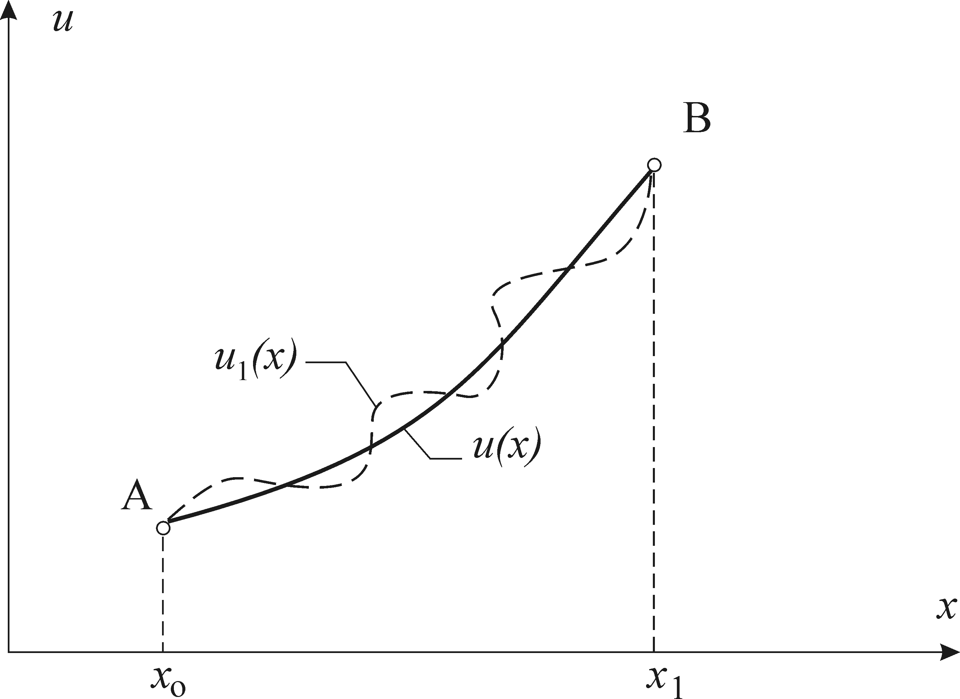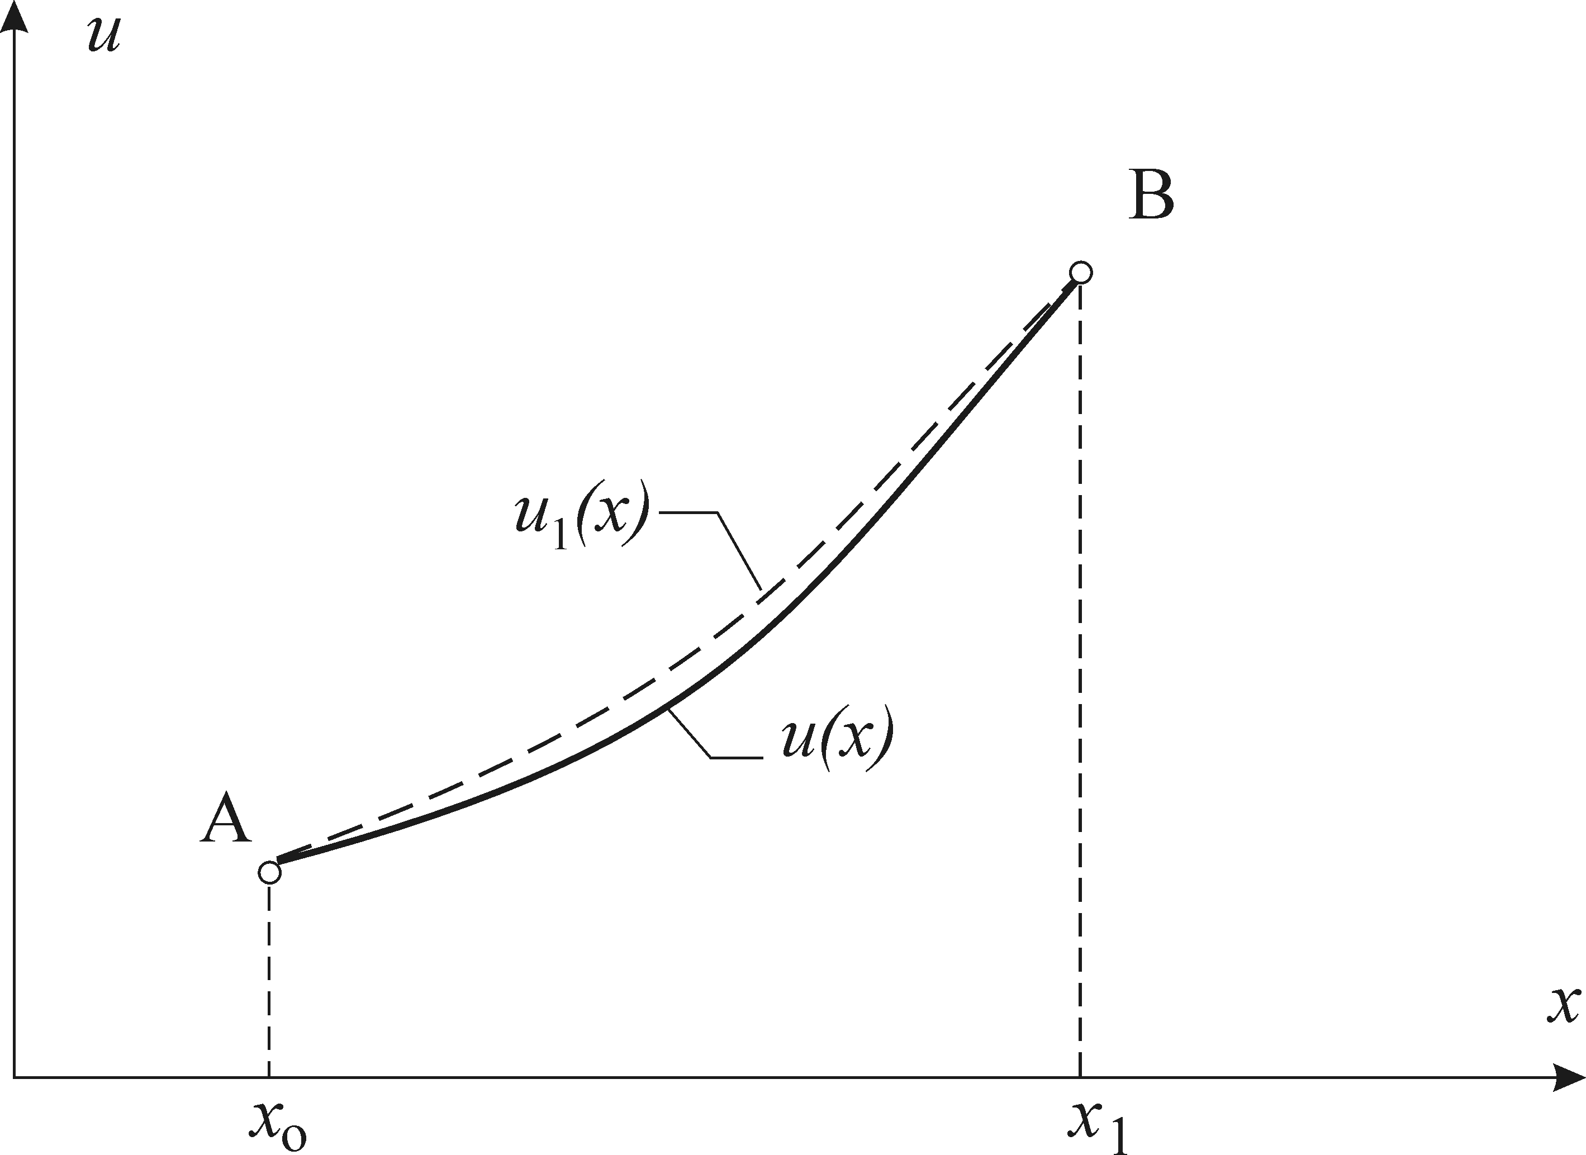
a) zero order nearness b) first order nearness
Figure 3

If the variation δи = и₁(х) - и(х) is differentiated with respect to the variable х, we will receive:
(1.8) $\frac{d}{\text{dx}}\left(δu\right)=\frac{d}{\text{dx}}\left(u_{1}−u\right)=\frac{{\text{du}}_{1}}{\text{dx}}−\frac{\text{du}}{\text{dx}}=δ\left(\frac{\text{du}}{\text{dx}}\right)$.
Here the symbols δ and $\frac{d}{\text{dx}}$ can change their places without an impact on the final result. This property is used in the derivation of the Euler Differential Equation, setting the conditions for the function и(х) which lead to the position were the functional I{и(х)} has an extremum. Here we can do an analogy with the requirement for the extremum of function (the derivative is zero), applied on the functional. We shall write only the final results for the functional of п independent functions I{и₁,и₂,…,и_{п}}= I{и_{i}}:
(1.9) $\frac{∂F}{∂u_{i}}−\frac{∂}{∂x}\left(\frac{∂F}{∂u'_{i}}\right)=0$ ( i = 1, 2,…, n).
For п=2 (functional of two arguments), и₁(х) и и₂(х) we have:
(1.10) $\frac{∂F}{∂u_{1}}−\frac{∂}{∂x}\left(\frac{∂F}{∂u'_{1}}\right)=0$ ,
$\frac{∂F}{∂u_{2}}−\frac{∂}{∂x}\left(\frac{∂F}{∂u'_{2}}\right)=0$ .
Double integrals and triple integrals are often used in practice. The necessary conditions for the extremum of these integrals are given by differential equations of Ostrogradski, which generalize the Euler equations corresponding to this case. For example for this functional:
(1.11) I{ z(х,y)}= $\iint{F(x,y,z_{(x,y)},\frac{\text{dz}}{\text{dx}},\frac{\text{dz}}{\text{dy}})\text{dxdy}}$ = $\iint{F(x,y,z_{(\text{xy})},n_{(\text{xy})},m_{(\text{xy})})\text{dxdy}}$ ,
corresponding equation appears as
(1.12) $\frac{∂F}{∂z}−\frac{∂}{∂x}\left(\frac{∂F}{∂n}\right)−\frac{∂}{∂y}\left(\frac{∂F}{∂m}\right)=0$ .

